**Minesweeper Documentation**

**Folder Structure**

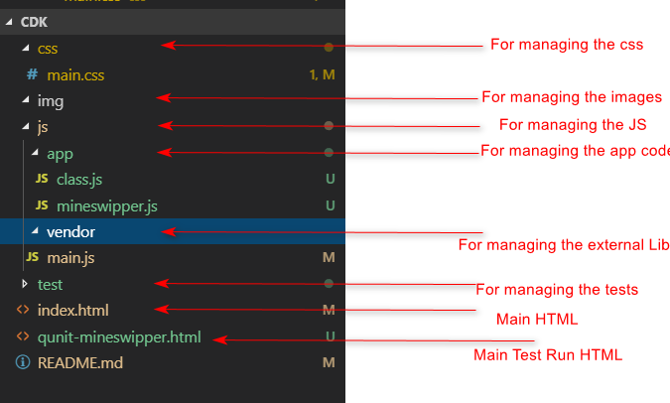

**Main.js**

* This file is use for initiating the Mineswipper.js code.
* I have created this file to separate out code dependency from the main code
* You can send 4 params while creating the instance of minesweeper class.
* I have added this params because if user want any modification then he/she can easily update the values in initialization.

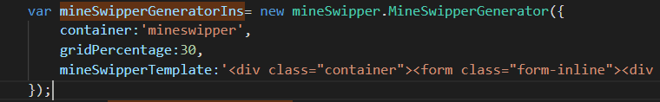

**Class.js**

* I have created this file for applying the OOPS concept
* Using this class you can create extend even you can use inheritance concept easily
* Added test cases for examples
* Find below example for use of classes
* If I want to inherit or extend or anything in Mineswipper class this is easy way and it will be helpful and applying OOPS concept

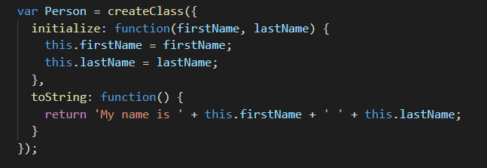

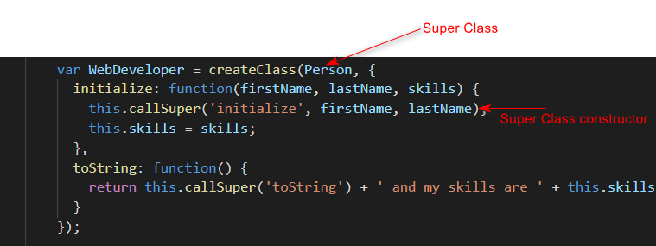

.

**MineSwipper.js**

* This file is managing the complete code of minesweepers game
* 